Athens, 17 March 2015
PRESS RELEASE
Third Travel Trade Athens Attracts Major Industry Interest
The third Travel Trade Athens workshop, which takes place in Athens on 26 & 27 April 2015, is attracting unprecedented interest among international buyers and suppliers in the Greek tourism industry. With the deadline for registration approaching on March 20 2015, the event is already close to full capacity.
Hosted by City of Athens Convention & Visitors Bureau (ACVB), in cooperation with the European Tour Operators Association (ETOA), Travel Trade Athens is the signature travel trade event for the Greek capital. 80 select buyers will participate, including tour operators, travel agents, and a high proportion of MICE organisers from around 20 countries such as the USA, Australia, Brazil, India, Turkey, Israel, Egypt, Finland, Germany, Italy, the United Kingdom and Romania.
Hosted buyers will have pre-scheduled B2B meetings with about 160 suppliers from the Greek travel and tourism sector. On 26 April, buyers will also have a full day to explore Athens and its environs on a choice of FAM trips, from island cruises to wine tastings and off-the-beaten-track tours led by locals. This year’s Travel Trade Athens is funded entirely by the European Union, so participation is free of charge.
“The increase in applications to attend Travel Trade Athens demonstrates that our long-term strategy to develop tourism, and the targeted actions of the Athens Development and Destination Management Agency and Athens Convention and Visitors Bureau, are bearing fruit,” said Athens Mayor, Yiorgos Kaminis. “Tourism is a pillar of the economy in Athens and the whole of Greece. Through careful planning, research, and partnerships, we are taking advantage of every opportunity to support and develop the tourism sector. We are also giving tourism businesses outside the capital the opportunity to benefit from Travel Trade Athens.”
Travel Trade Athens 2015 is supported by the United Nations World Tourism Organization (UNWTO), International Gay & Lesbian Travel Association (IGLTA), World Youth Student and Educational (WYSE) Travel Confederation, and Meeting Professionals International (MPI), and Adventure Travel Trade Association.

Travel Trade Athens was recently honoured at the Greek Tourism Awards 2015 in the Strategy & Innovation category for its successful sales strategy. Over 3,500 individual meetings between buyers and Greek suppliers took place during the two previous Travel Trade Athens workshops.

For further information, please contact:

Kalliopi Andriopoulou, Director of Public Relations
kandriopoulou@developathens.gr
+30 210 3253123

Orhideea Rosu, Travel Trade Sales & Marketing Manager
orhideea@athenscvb.gr
+30 210 3312002

The logo of the City of Athens annual Travel Trade Workshop

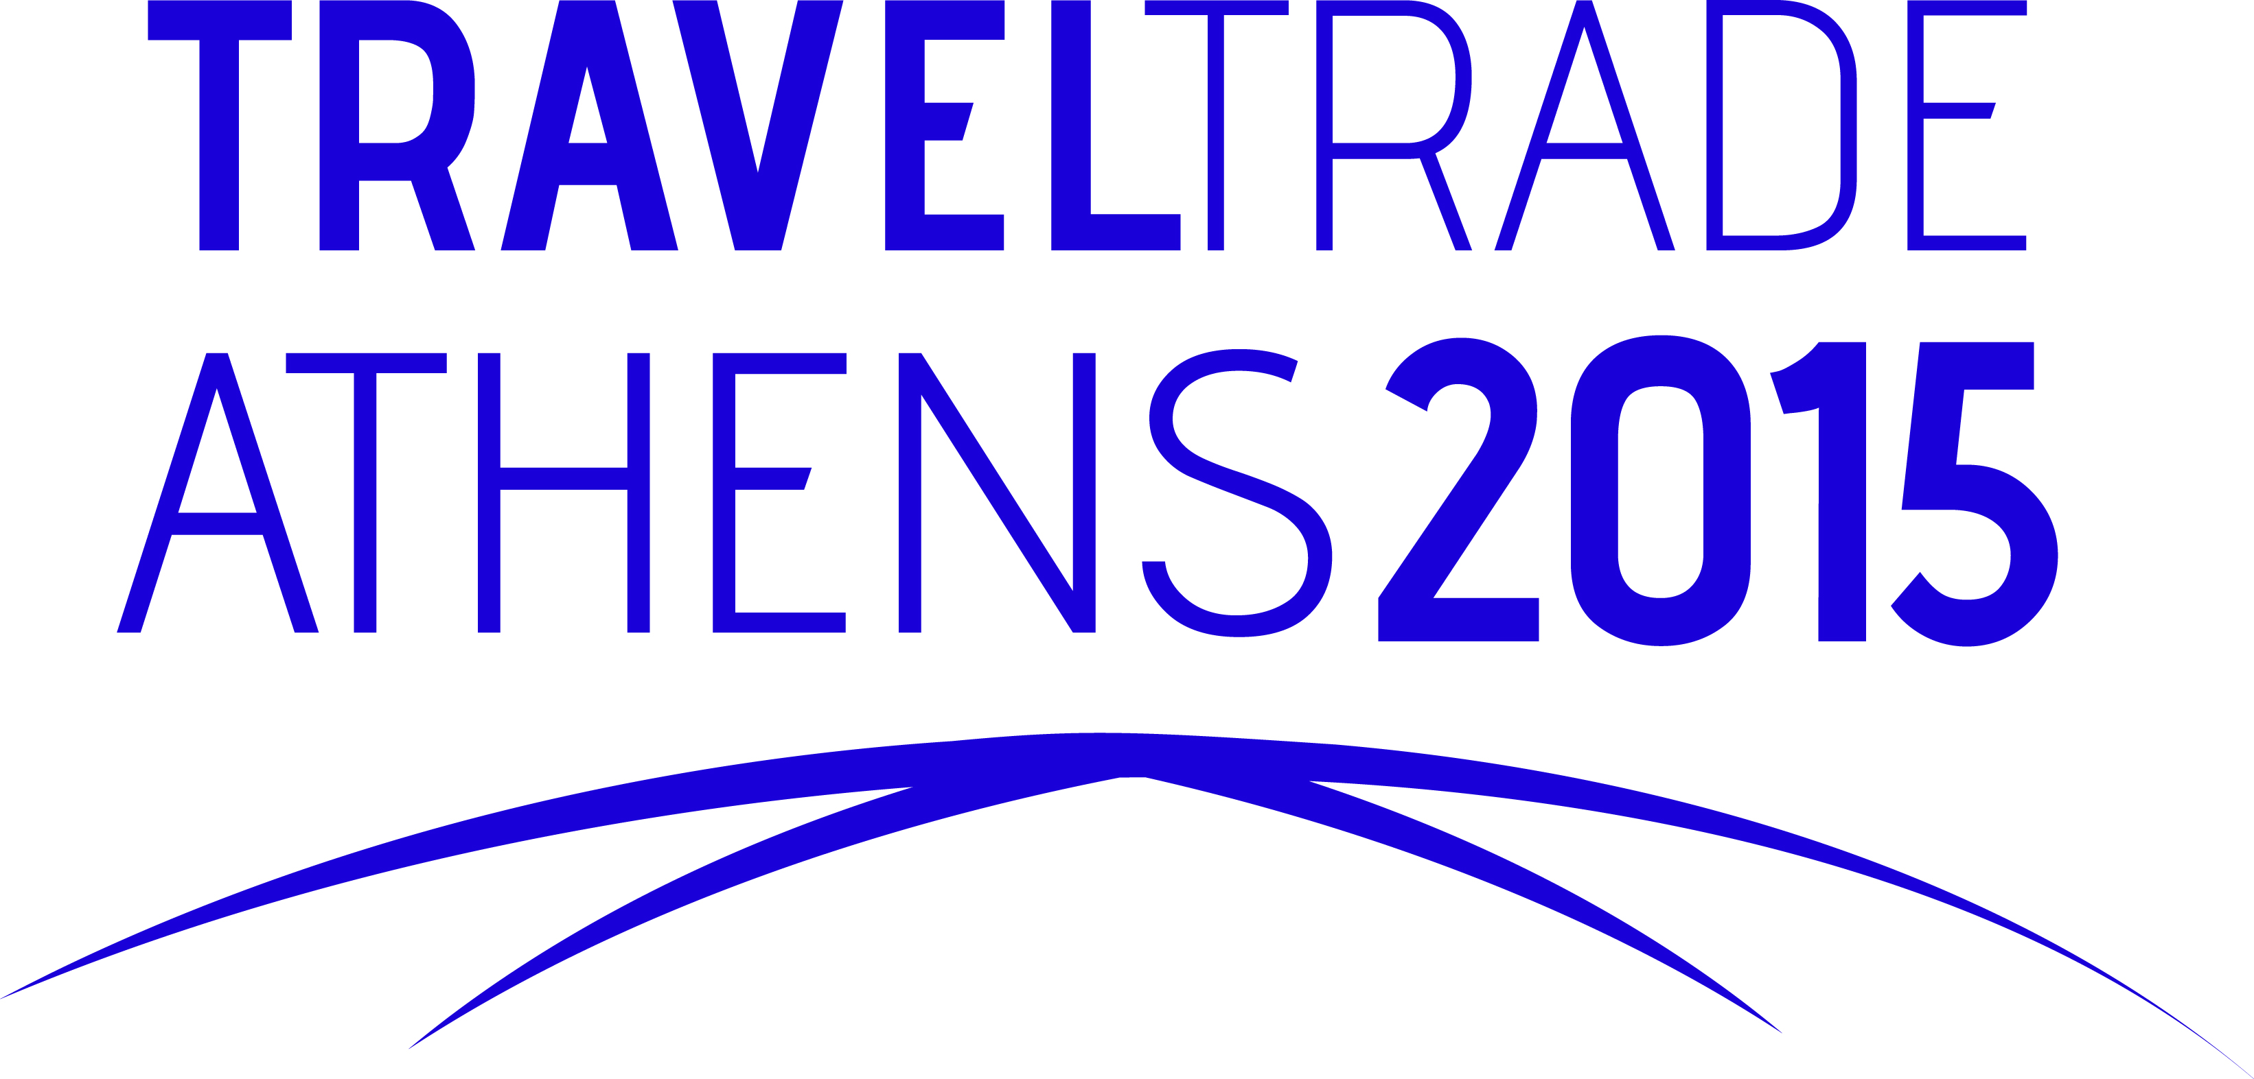

Date: April 26 & 27, 2015
Venue: Megaron Athens International Conference Center

www.traveltradeathens.gr
traveltrade@athenscvb.gr

